Session -1

Assignment-1

**Problem Statement :** Write a program to print the sum of two numbers. One number should be int and another should be float.

**Code:**

**import** java.util.Scanner;

**public** **class** Additions_1_1 {

**public** **static** **void** main(String[] args) {

Scanner input= **new** Scanner(System.***in***);

System.***out***.print("Enter first input:");

**int** x=input.nextInt();

System.***out***.print("Enter Second input:");

**float** y=input.nextFloat();

**int** sum=(**int**) (x+y);

System.***out***.print("Sum of two numbers are :" + sum);

}

}

**Output:**

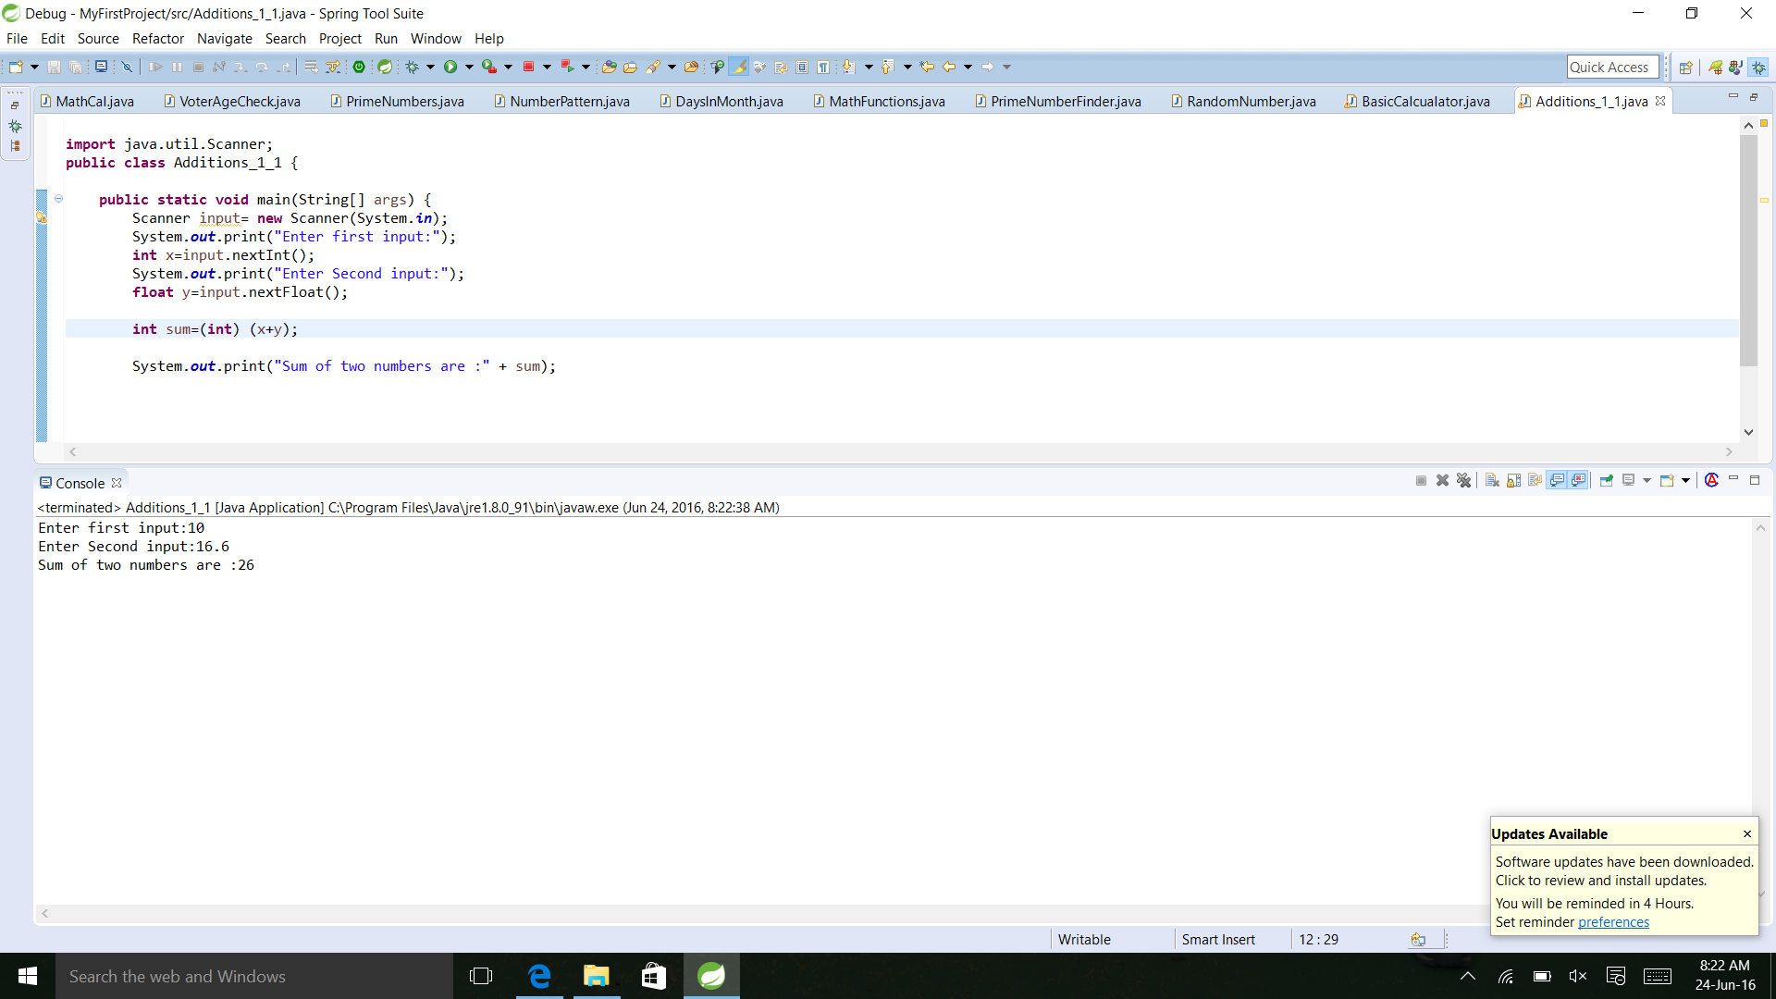

Assignment-2

**Problem Statement:** Declare three integer variables (a,b,c) in a single declaration and simultaneously initialize b to 4.

**Code:**

**public** **class** DataTypes_1_2 {

**public** **static** **void** main(String[] args) {

**int** a,b=4,c;

a=c=0;

System.***out***.print("Values of a: "+a+" value of b: "+b+" value of c: "+c);

}

}

**Output:**

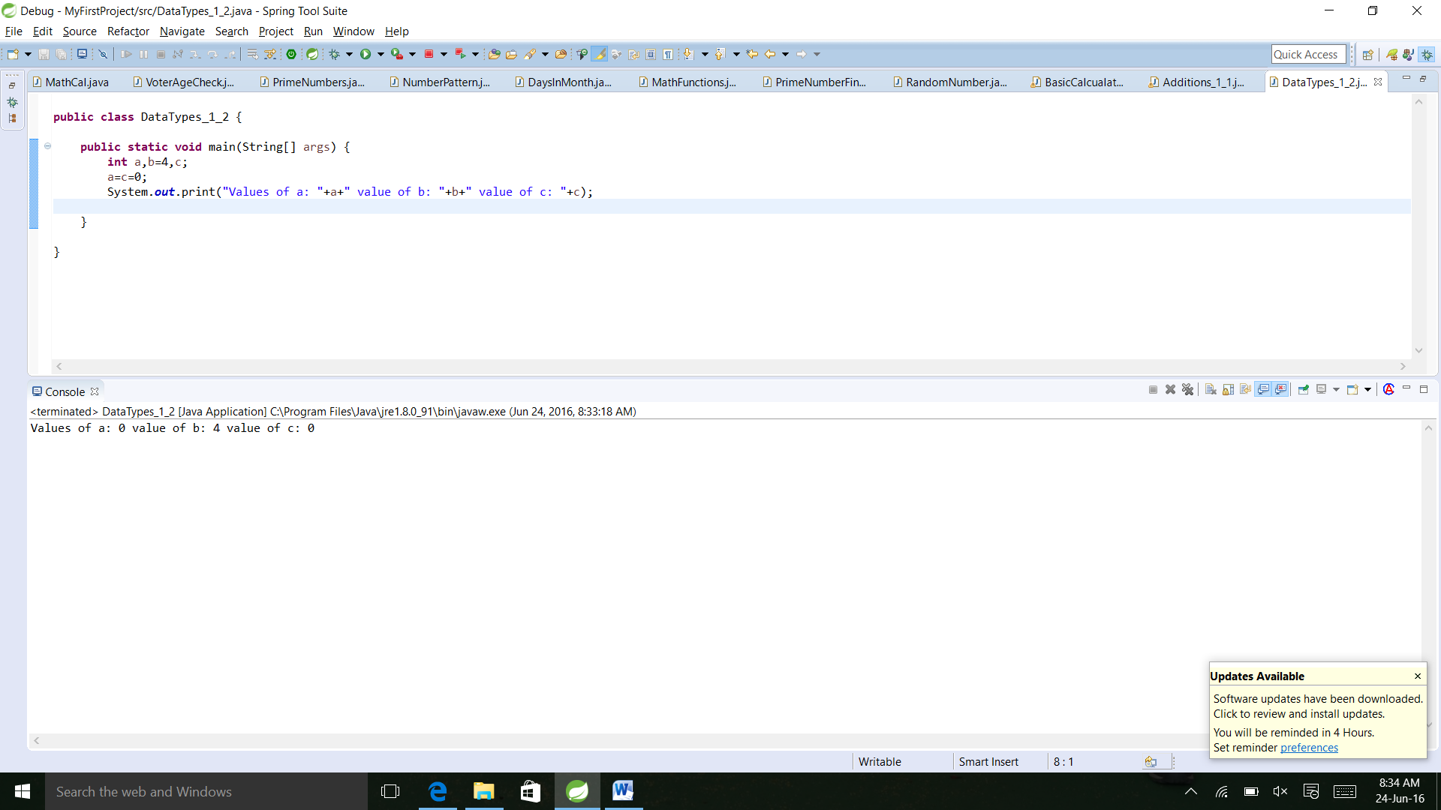

Assignment -3

**Problem Statement:** Give two examples of data that cannot be stored in a variable of type int.

**Code:**

**public** **class** Integer_1_3 {

**public** **static** **void** main(String[] args) {

**int** x,y;

**boolean** ch=**true**;

String str="abcd";

x=ch;

y=str;

}

}

**Output:**

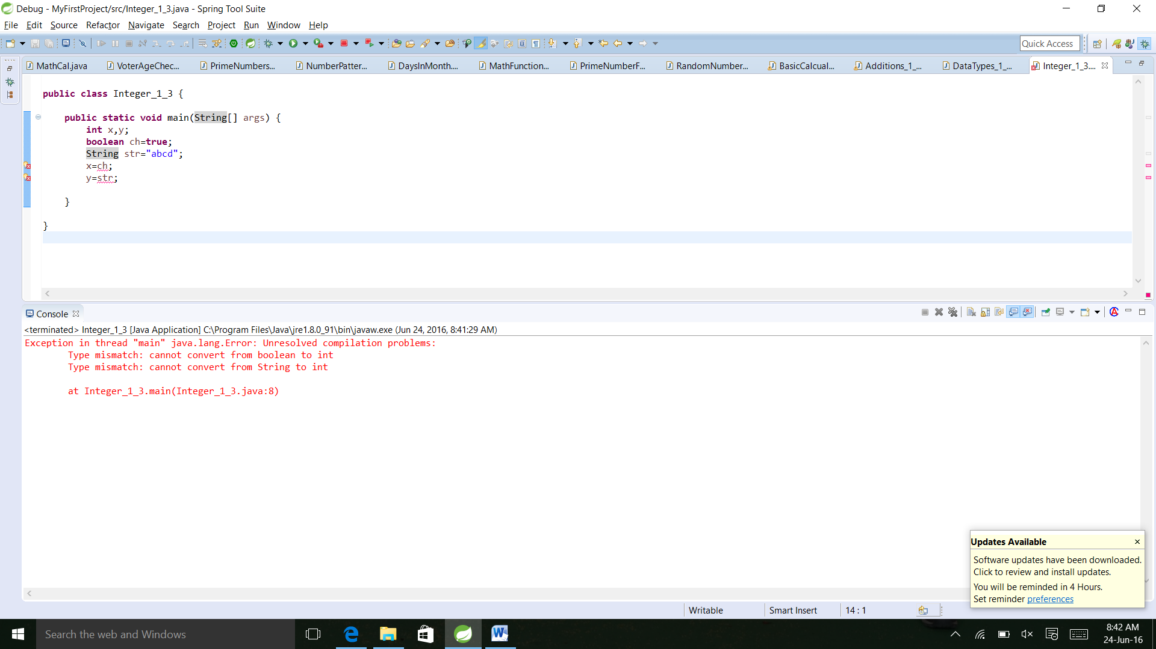

Assignement-4

**Problem Statement:** Assume that the integer variable x is 5 and the integer variable y is 10. Give the values of the following expressions:

a. x + y * 2

b. x - y + 2

c. (x+y) * 2

d. y % x

**Code:**

**public** **class** ArithmeticOps_1_4 {

**public** **static** **void** main(String[] args) {

**int** x=5,y=10,res;

res=x+y*2;

System.***out***.println("Result of x+y*2: "+ res);

res=x-y+2;

System.***out***.println("Result of x-y+2: "+ res);

res=(x+y)*2;

System.***out***.println("Result of (x+y)*2: "+ res);

res=y%x;

System.***out***.println("Result of y%x: "+ res);

}

}

**Output:**

